

**Information Literacy Module:**

**Research Skills**

**Directions**: View the **Research Skills** power point which is posted in Handouts in the Information Literacy Unit page link in your course on STInet. Then, answer the following questions:

1. Why is it important for YOU to acquire research skills?  
   **Research skills helps to find resources for reference.**
2. What is information literacy?  
   **Information literacy is the ability to successfully find, retrieve, analyze, and use research or information for an academic purpose**
3. List the 3 ‘rules of thumb’ in doing research.  
   **Start early, be organized, and research on subject.**
4. Name 2 types of sources used to find background information on the subject.  
     
   **Newspapers and magazines**
5. Name 2 types of sources used to find up-to-date information.  
     
   **School journals and magazines**
6. Name 1 type of source of comprehensive information.  
    **Periodical Literature**
7. To find periodical literature on your research topic what should you consult (where should you look)?  
     
   **The first place to look for periodical literature is the school library page.**

1. Name two distinct characteristics of scholarly journals.  
     
   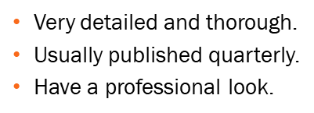
2. Name two distinct characteristics of popular magazines.  
     
   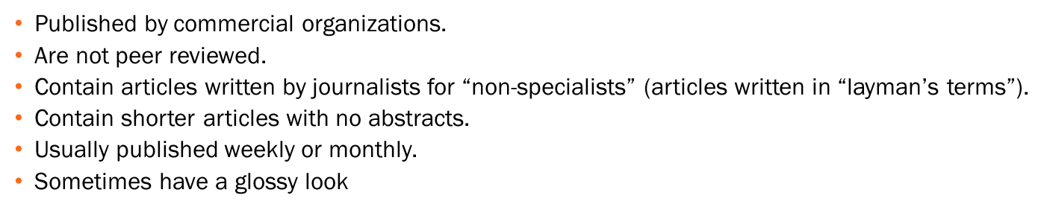
3. Name two distinct characteristics of newspapers.  
   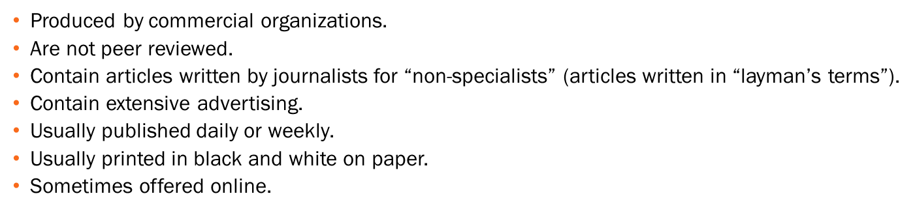
4. Name one reliable search engine.
   * 1. [www.ipl.org](http://www.ipl.org/)
     2. [www.digital-librarian.com](http://www.digital-librarian.com/)
     3. [www.infomine.ucr.edu](http://www.infomine.ucr.edu/)
     4. [www.scholar.google.com](http://www.scholar.google.com/)